**Cluster** contains nodes

**Nodes** contains pods

**Pods** have containers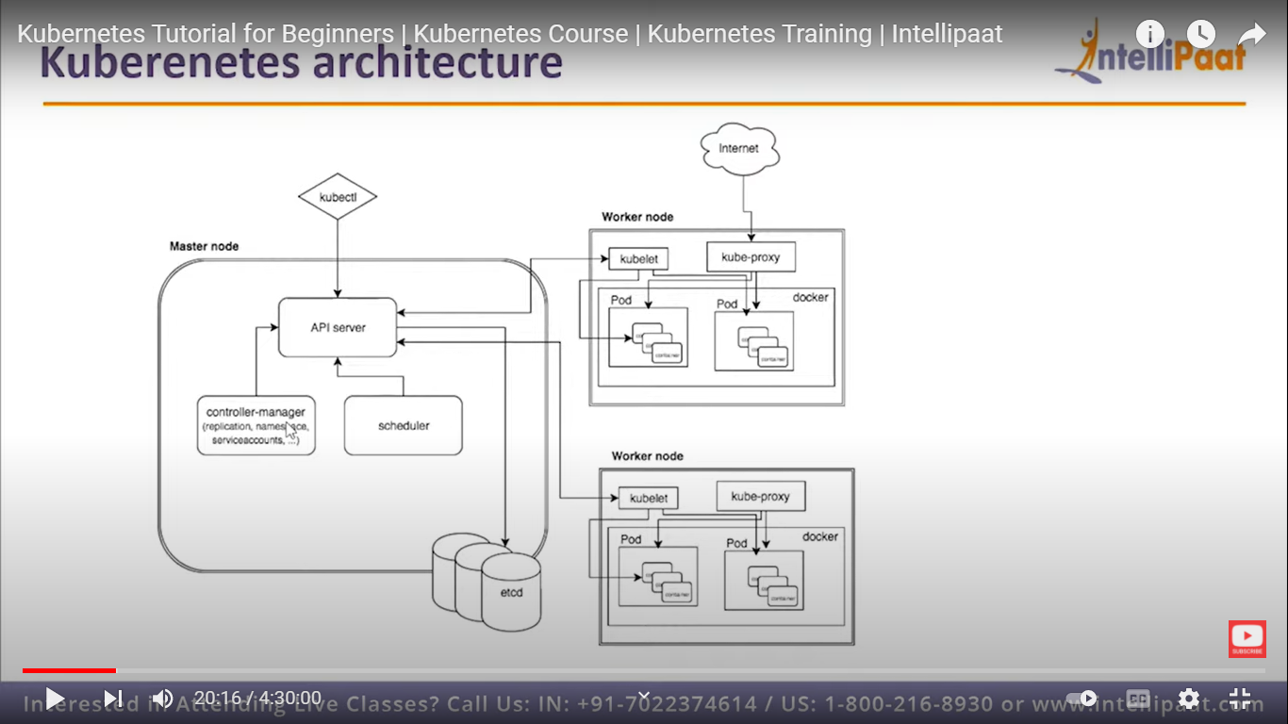

The job of **master** (control plane) is to coordinate the entire cluster

The job of nodes is to run the pods.

**kubectl**.

1. The Kubernetes **command-line tool**, **kubectl**, allows you to run commands against Kubernetes clusters.
2. It interacts with the kube-api server and sends commands to the master node.
3. And here each command is converted into an API call.

What is **etcd**?

1. It is key value store for all the data.
2. **Etcd** is the cluster database
3. And its job is to reliably store the state of the cluster
4. It contains all the cluster configuration data and dynamic information like what nodes are part of the container and what pods should be running and where they should be running.
5. Only kube-API has access to etcd contains all encrypted data in **etcd**

**Kube API-Server**

Job is to accept the commands and launch the pods using **kubectl** commands

* It provides all the operations on the cluster using API.
* API server implements interface which means different tools and libraries can readily and communicate with it.

**Kube-config:** It is a package along with the server side tools that can be used for communication. It exposes k8s API.

* Kube-api server is **designed** to scale **horiantally** --that is, it scales by deploying more instances.
* You can run several instances of **api-server** and balance traffic between those instances.

**Kube-controller manager**

1. Its job is to continuously **moniter** the state of the cluster (I.e**: Nodes go down**) through **kube API** server.

EX: When the state of the cluster dosen’t meet the desired state this manager attempts changes to achieve desired state

1. Many kubernestes objects are controlled by loops of code called controllers.

* **Replication Controlle**r is one of the key features of Kubernetes, which is **responsible for managing the pod lifecycle**.

**Replication Controlle**r: Responsible for maintaining the correct number of **pods on node** for every replication controller object in the system.

**End-point controllers:** Populates the end point objects like ( I.e: joins services and pods)

Service account & token controllers : Creates default accounts and API access tokens for **new namespaces.**

**Kube-cloud manager:**

* cube cloud manager manages controllers that interact with the underlying cloud providers.
* It allows vendors code(I.e: AWS or GCP) and k8s code evolve idependently of each other.

**Kube-scheduler**

1. It is responsible for allocating pods on to nodes.
2. And responsible for distributing the **workload.**
3. It schedules where the pod sholud be run and where to run.
4. Responsible for tracking the utilization of workloads on pods.

How **kube-scheduler** knows where to run the pod?

1. it knows the state of all or each node.

**POD**

* A pod is a group of containers in a shared networking and storage.

**Container run-time:**

* It is a software responsible for running the containers.
* **Kubernetes** supports several container run times like

Ex: **Docker**,containaried,cri-o,rklet

**Kubelet:**

* Kubelet uses the container run time(**docker**) to start the pods and moniter its lifecycle including readiness and liveness reports back to the kube API server.(etcd) to store data.
* Its main job is to interact with the **etcd** and read & store the configuartion details.
* It receives commands from the master node and then takes responsibility for maintaining the state of work and the node server. i.e: manages network rules,port forwarding.

**Role of kubelet:**

To serve as Kubernetes’s agent on each node.

**Kube-proxy service:**

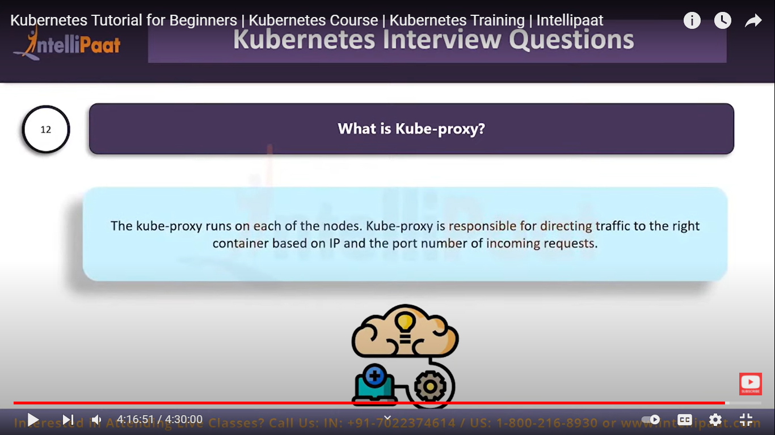

* Cube proxy's job is to maintain the **network connectivity** among the pods in a cluster in open source kubernetes it does so using the firewall capabilities of iptables.

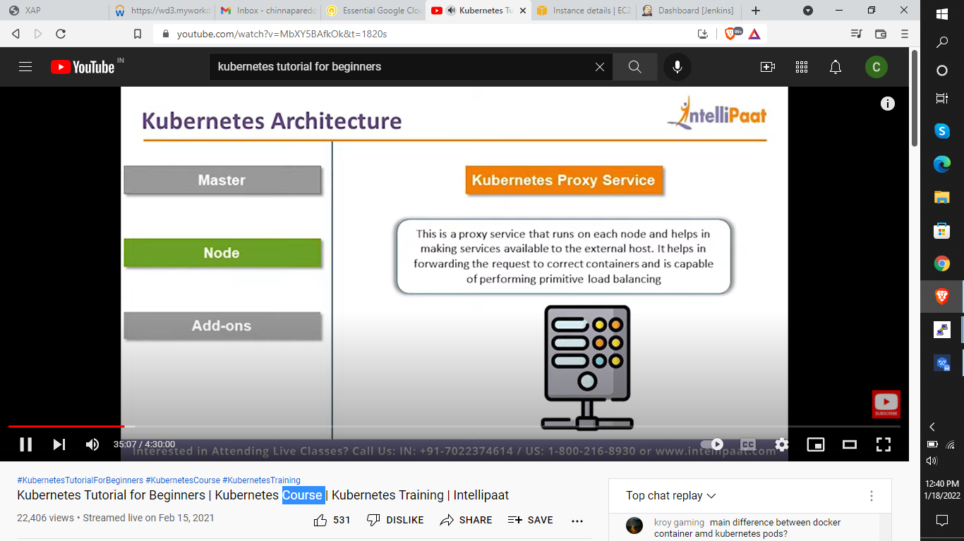

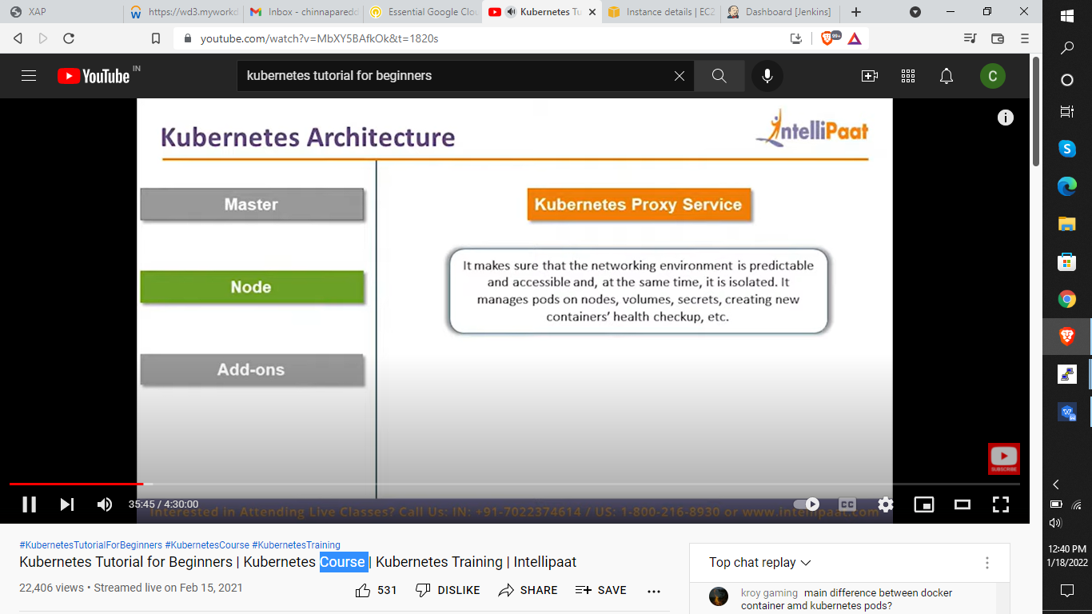

**What are Kubernetes Add-ons?**

* In short, add-ons **extend the functionality of Kubernetes**. There are many of them, and chances are that you already using some.
* For example, network plugins or CNIs like Calico or Flannel, or CoreDNS (now a default DNS manager), or famous Kubernetes Dashboard.

Kubernetes add-ons:

* The open-source **Kubernetes** platform is **designed to help simplify application deployment through Linux containers**.
* It supports tasks like deploying workloads in the form of pods, clustering nodes, managing container runtimes, and tracking.

**Kubernetes Objects:**

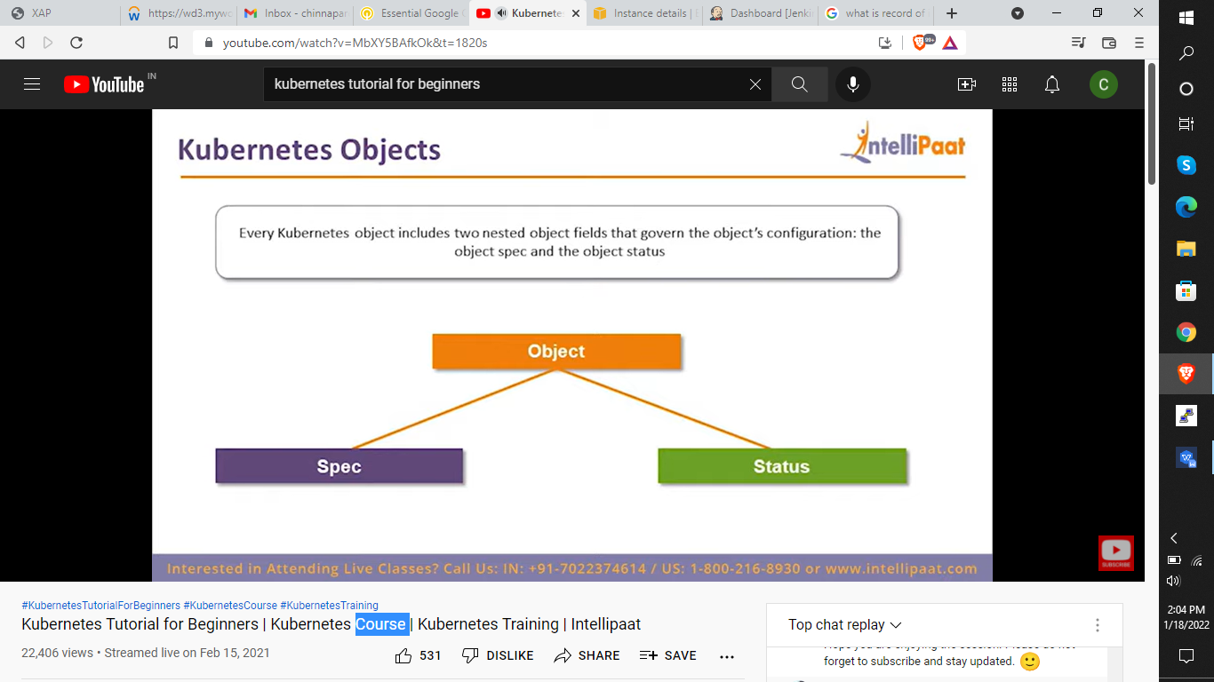

**What is spec?**

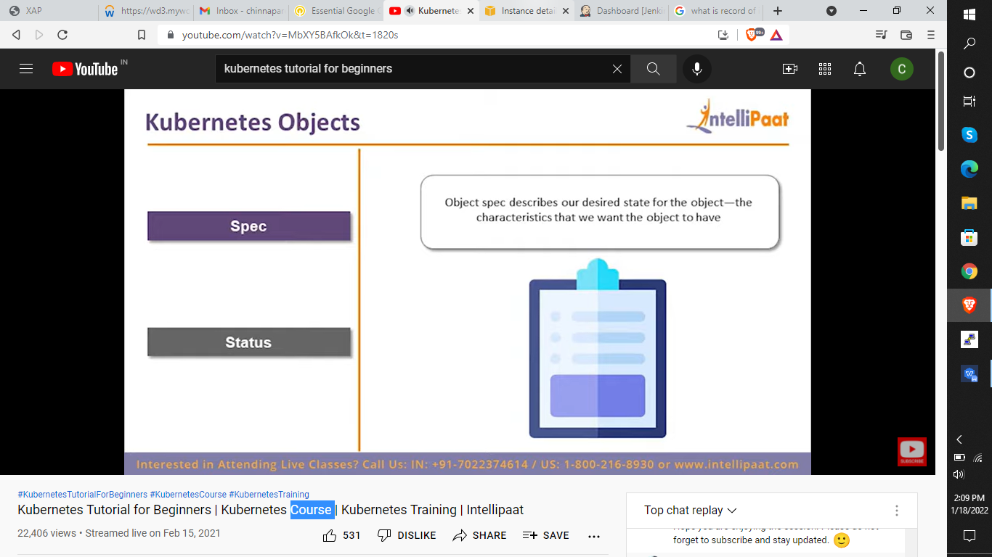

* It describes our desired state of the object---the characterstics that we want the object to have (on cluster like what type of…u need)

**Object Status:**

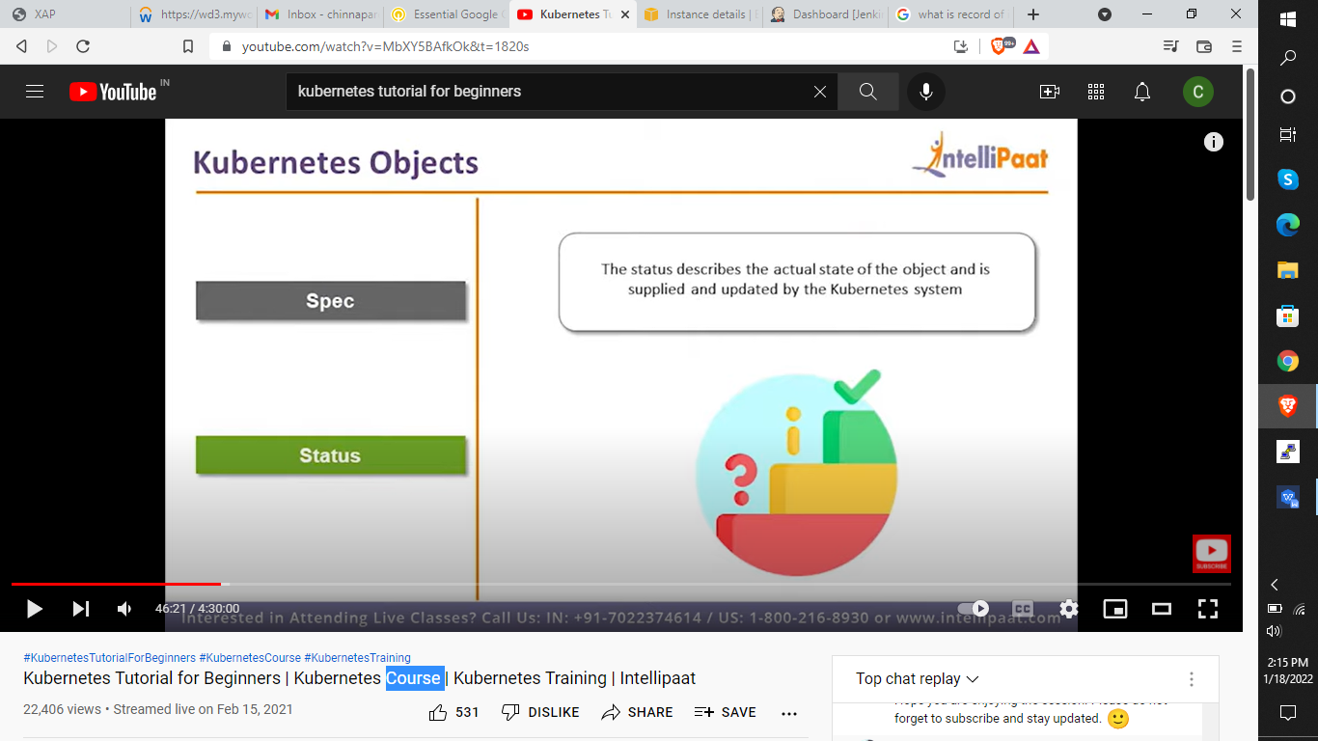

**Kubernetes additional concepts:**

1. Name
2. Namespaces

**Namespace** -

* Namespaces are **a way to organize clusters into virtual sub-clusters** — they can be helpful when different teams or projects share a **Kubernetes cluster**.
* Any number of namespaces are supported within a cluster, each logically separated from others but with the ability to communicate with each other.

1. Labels and selectors
2. Field selectors
3. Annotations

**Kubectl basic commands:**

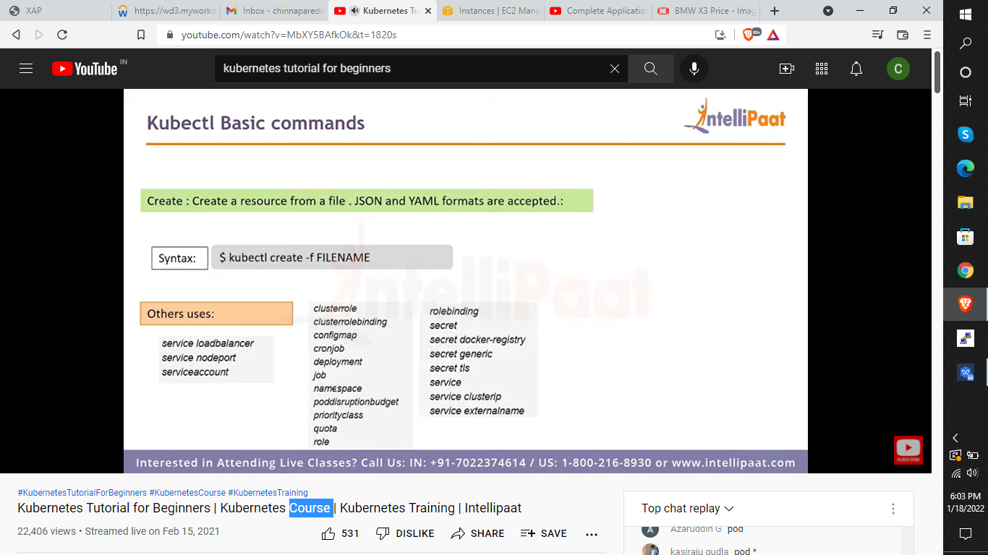

**Ex:** kubectl create -f nginx-deployment.yaml

Or

Without .yaml file also we can deploy the nginx with direct command

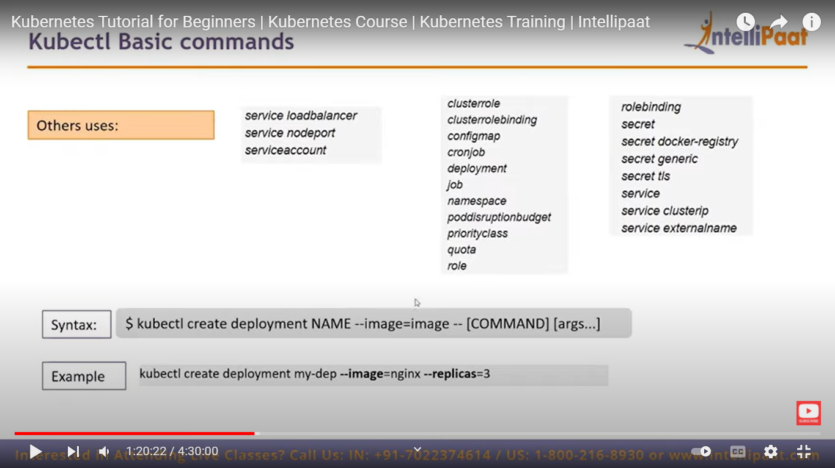

Here my-dep is just deployment name

i.e: kubectl create deployment mydep --image=nginx --replicas=5

* Kubectl get pods --all-namespaces
* This will display the all the pods with different or unique name.
* Kubectl get pods -o wide
* Lists pods with some more information.

**Expose:**

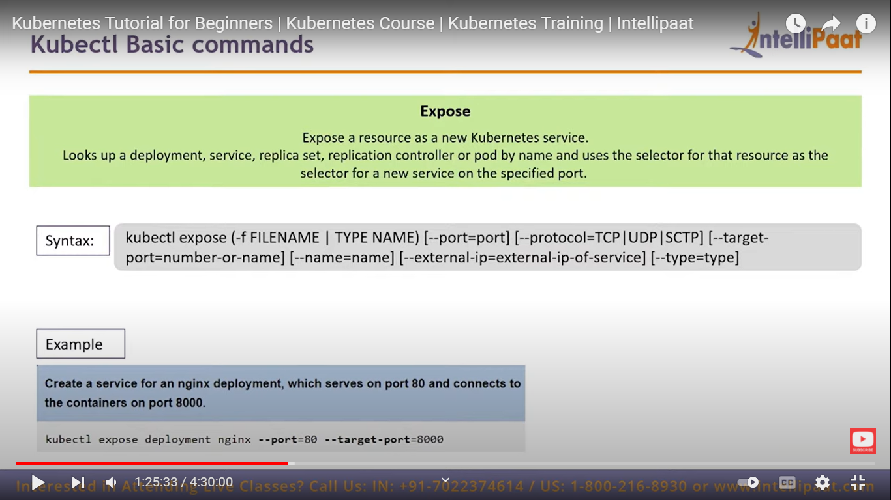

i.e: kubectl expose deployment mydep --port-=80 --target-port=8080

**Delete**

**pods:**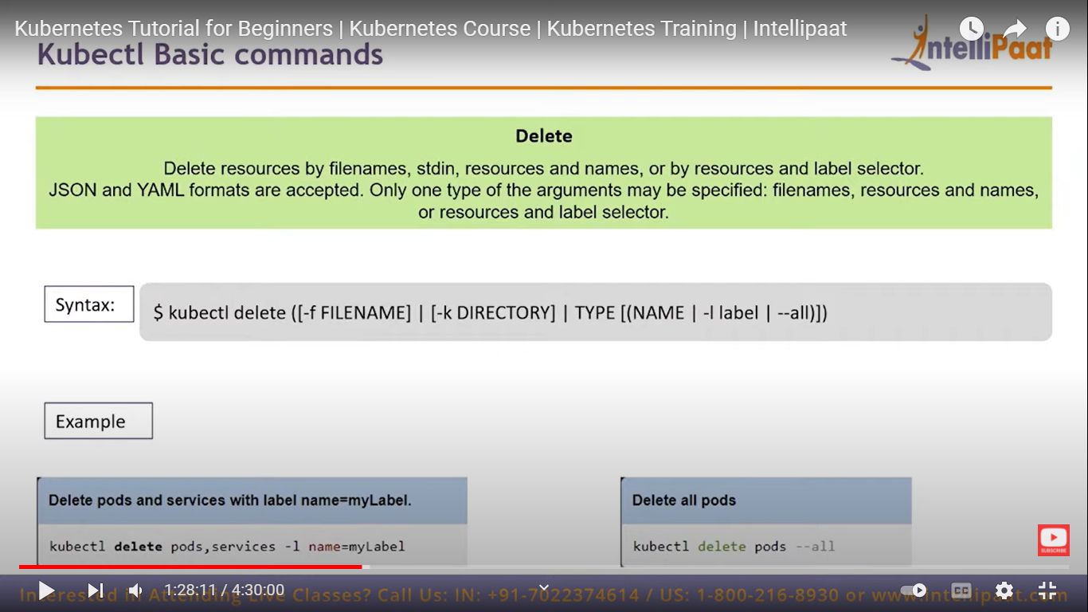

**Kubectl delete -f .yaml**

It delets only the pods that have created with that file

**Kubectl delete pod “**pod name” deletes that particular pod.

**Autoscale**:

It autoscales the pods i.e: increases or decreases the count of pods according to the traffic.

**Ex:** kubectl autoscale deployment foo --min=2 --max=10

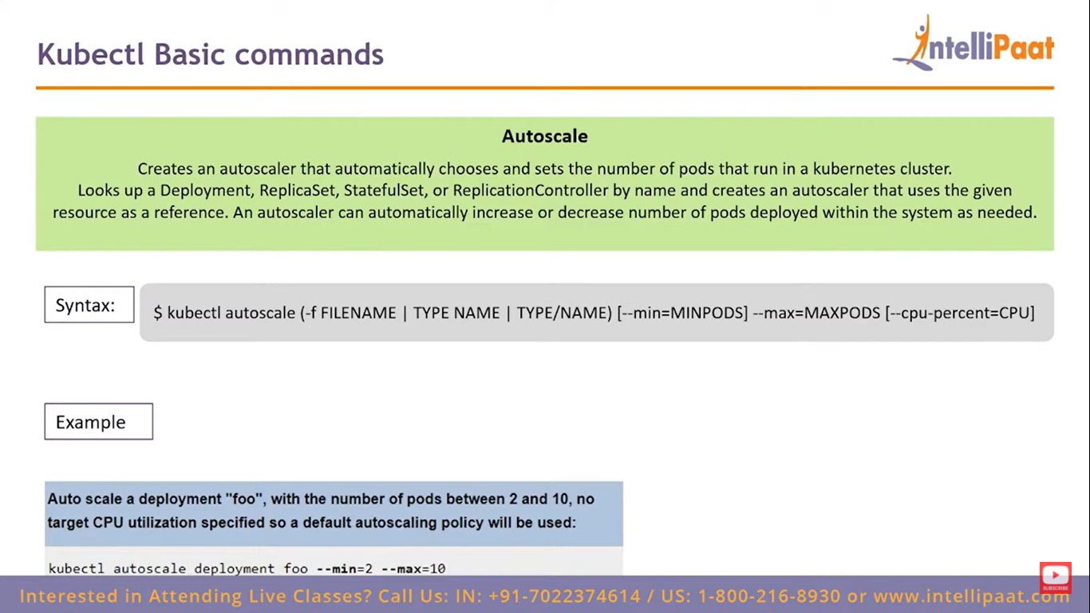

**SCALE:**

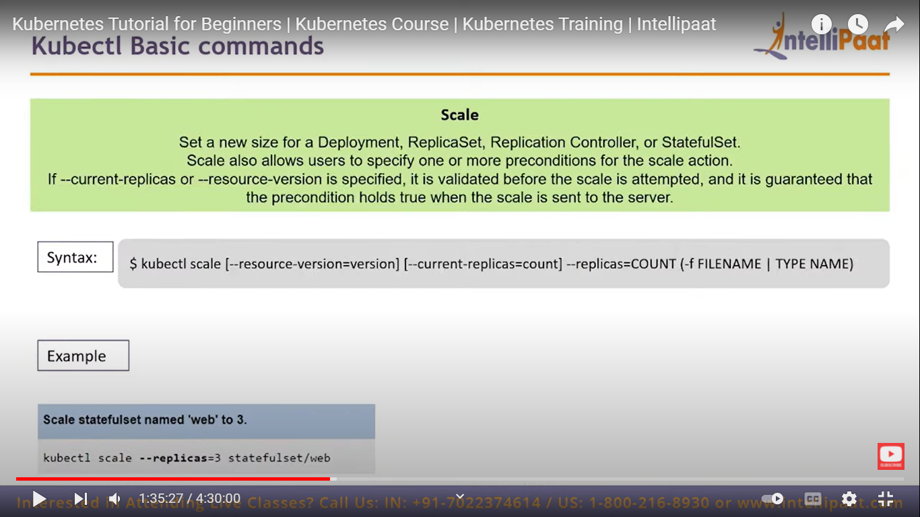

**Ex:** kubectl scale --replicas=3 deployment mydep

**Describe:** It prints detailed description of selected resources such as events and controllers

**EX**: kubectl describe pods ‘pod name’

**Logs:** Gives logs of that particular pod

**Ex:** kubectl log ‘pod name’

**If you want to expose your pod externally on internet use this command:**

* kubectl expose pod “httpd-5b9c4df55f-6z68j” --name=httpd-svc --port=80 --type=NodePort

**Exec:**

**Ex:** Kubectl exec pod name -- date (space is must after two coluns)

**If we want to enter into the pod :**

* **kubectl exec -it “nginx-dep-d46f5678b-4w79m” -- /bin/bash**
* The index.html file is presnt in /usr/share/nginx

**Labels:**

* kubectl label pods “pod name” label name
* kubectl get pods --show-labels ----- To view the label of that particular pod

**Volumes:** Used to store data present in the pods

**Tyeps of Pods:**

1. **Persistance volumes**
2. **emptyDir volume** -- it is a type of volume that is created when the pod is assigned to a node. It remains active as long as the pod running on the node.

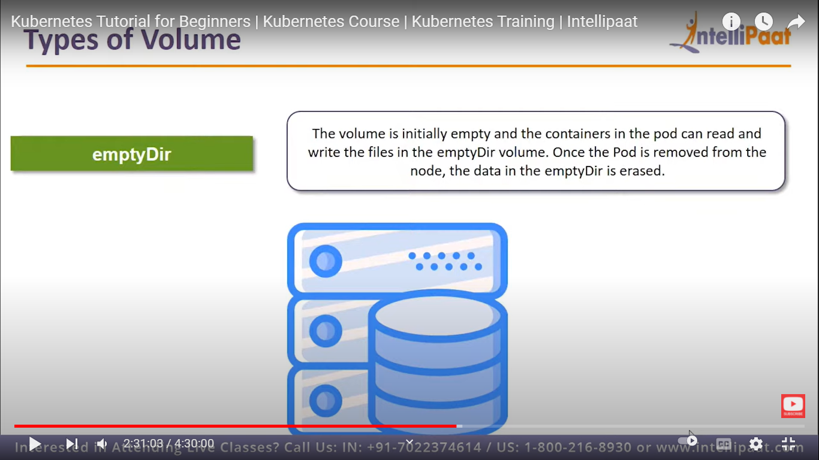

1. **Host path:** Here the host is nothing but the master node

* It is used to mount a file or directory from the **host node'**s file system into our pod.

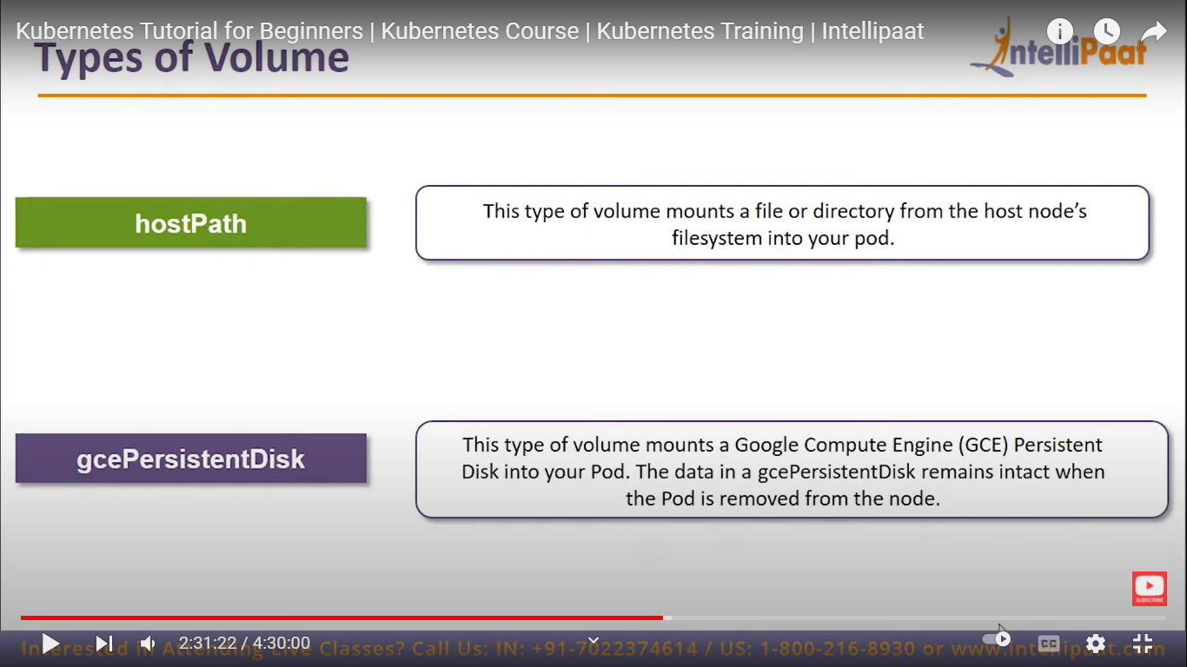

1. **Gcepersistance disk:**
2. **AWS Elsatic blockstore:**

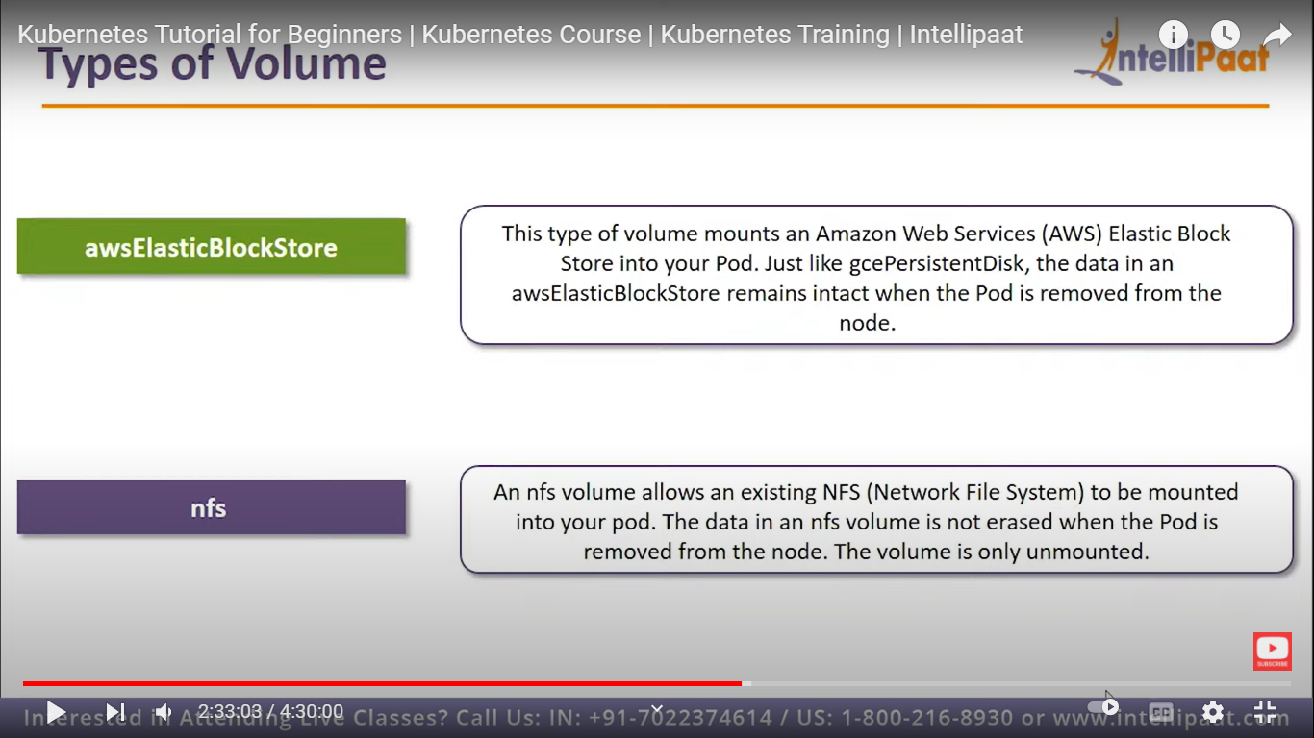

1. **Nfs (network file system):**



1. **Iscsi volume:** 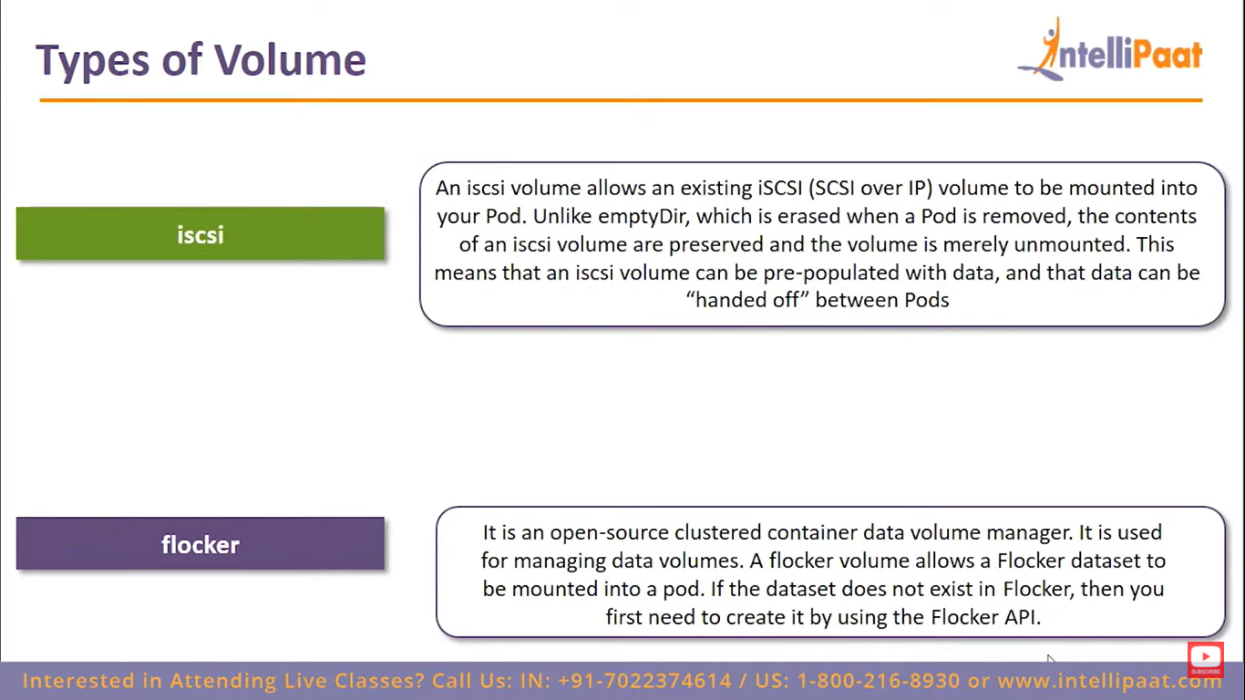
2. **Flocker volume:**



1. **Glusterfs volume:**

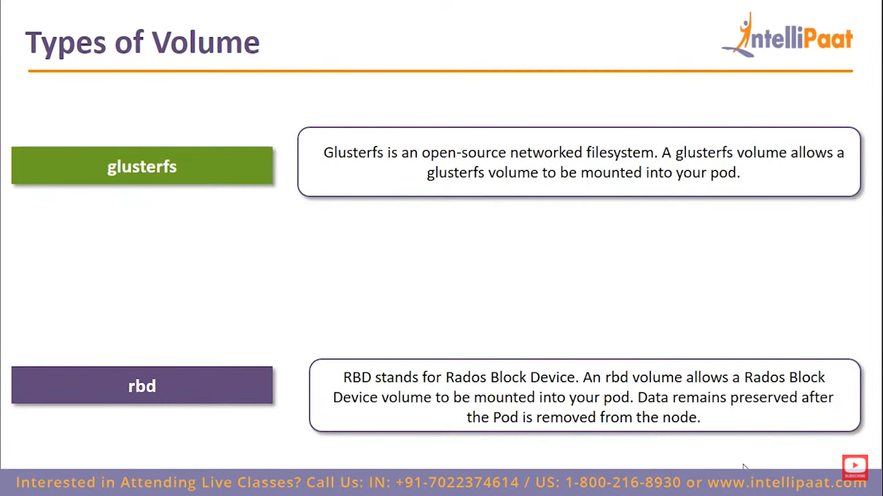

1. **Rbd volume (Rados block device):**



1. **Cephfs volume:**

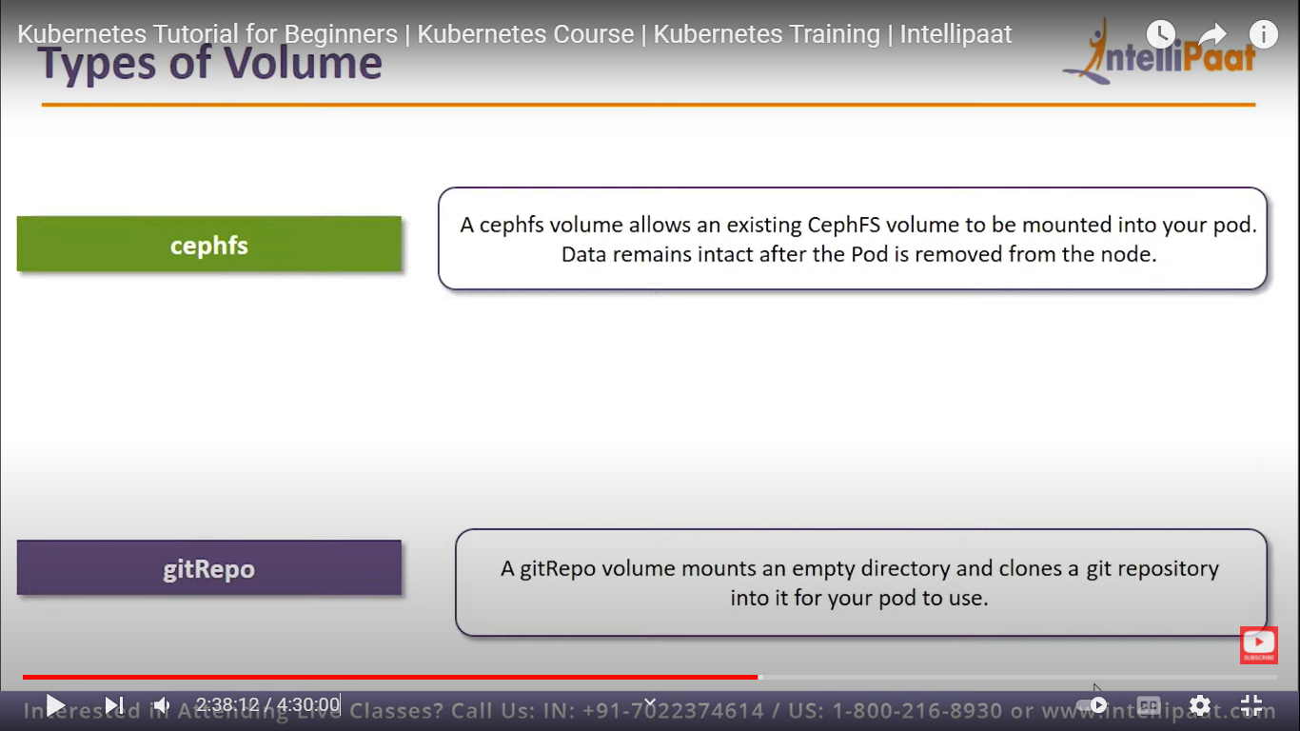

1. **gitRepo volume:**



1. **Secret volume: (very important volumes)**

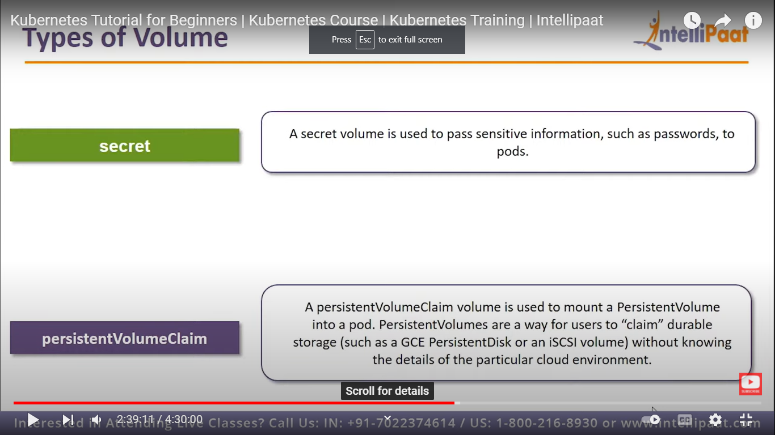

1. **Persistance volume claim: (important)**



1. **Downward API volume**
2. **AzureDisk volume**

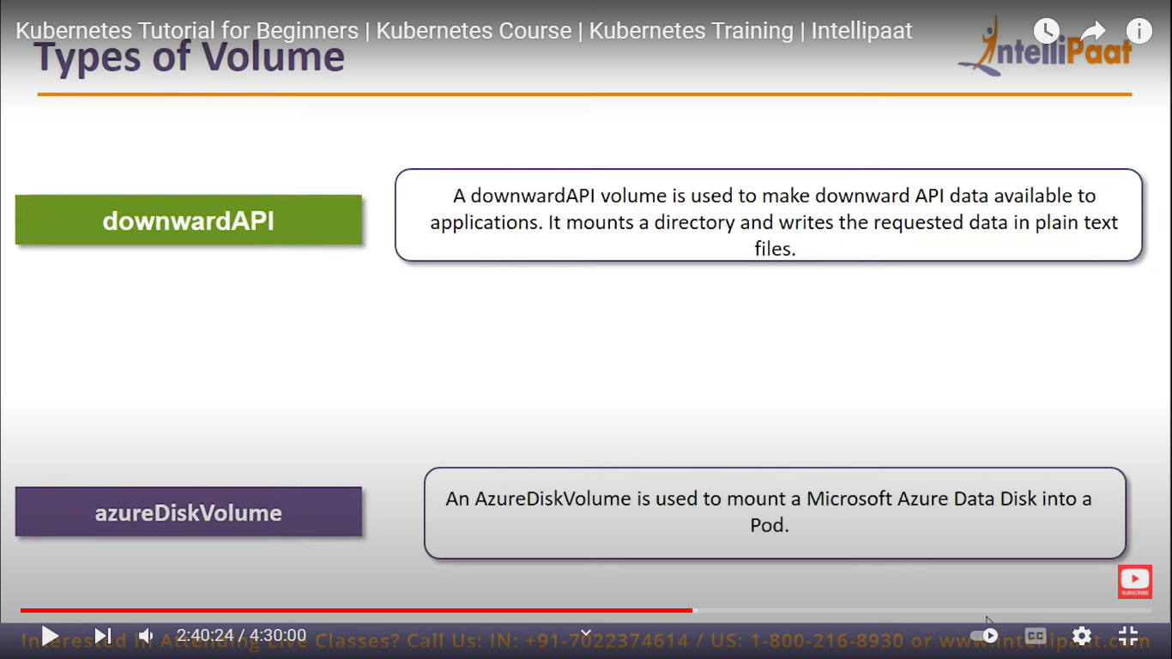

**For creating persistance volumes:**

<https://github.com/kubernetes-retired/external-storage>

**Kubectl get pvc**

**Replication controllers:** To manage the lifecycle of the pod.

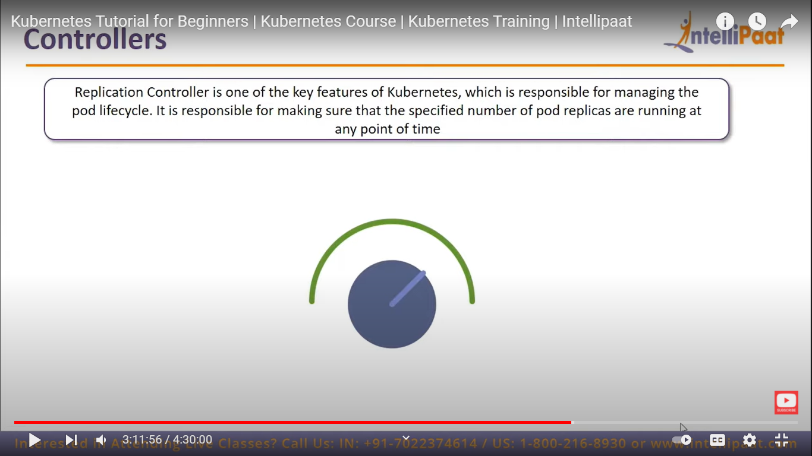

**Kubectl get rs** ----- it gives you the replica sets created

**DEPLOYMENTS:**

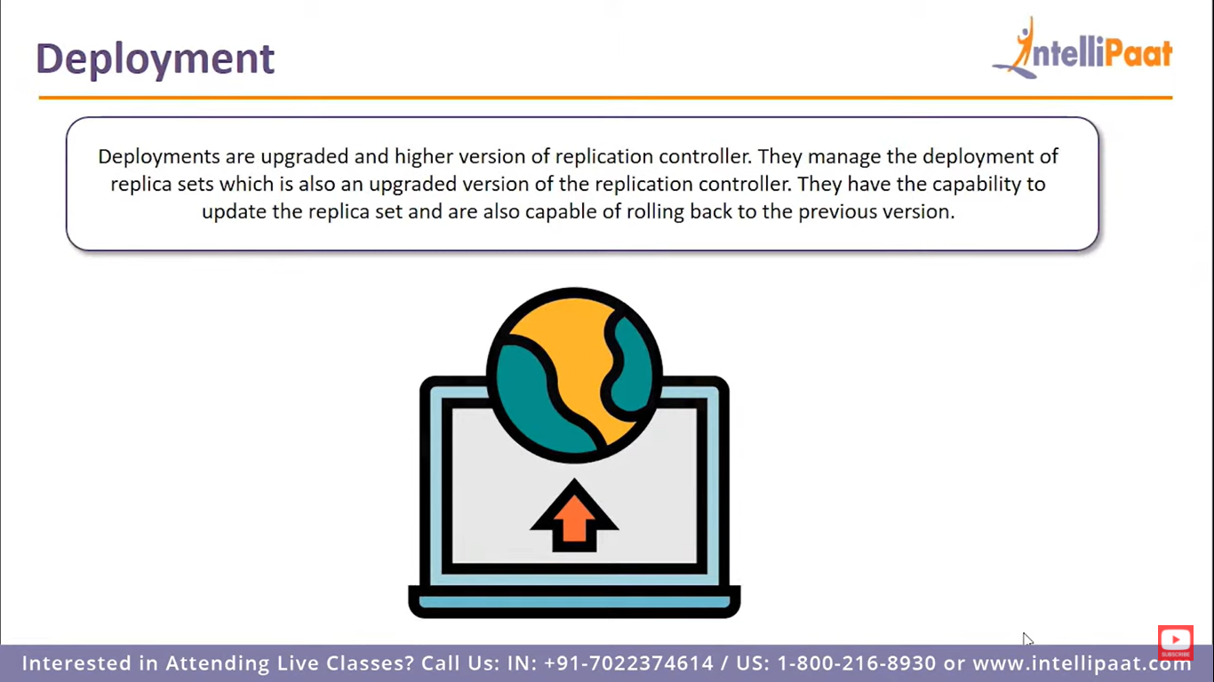

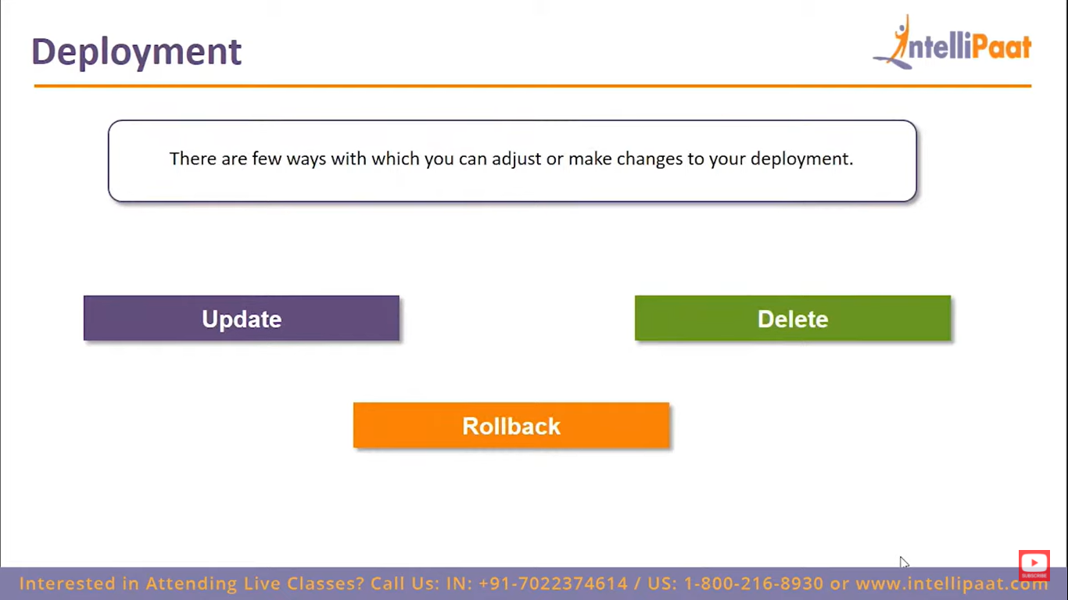

Rolling updates **allow Deployments' update to take place with zero downtime by incrementally updating Pods instances with new ones**

**Kubectl create -f deployments.yaml**

* Pods will be created according to the replicas you have given
* So, if we update want to update our pod now

**kubectl set image deployments/nginx-deployment nginx=centos:**07

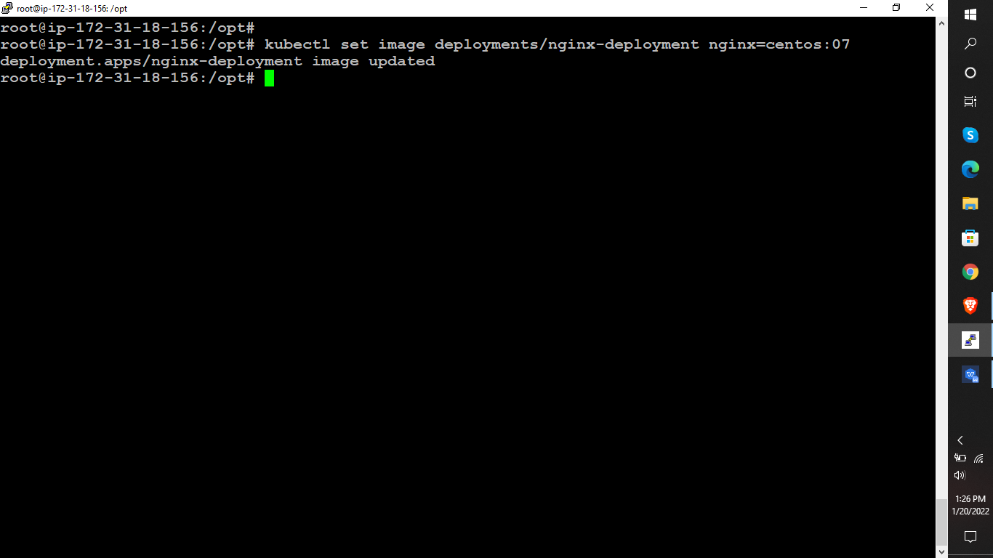

* To view the status of the updated deployement
* **kubectl rollout status deployments/nginx-deployment**

**Rollout history**

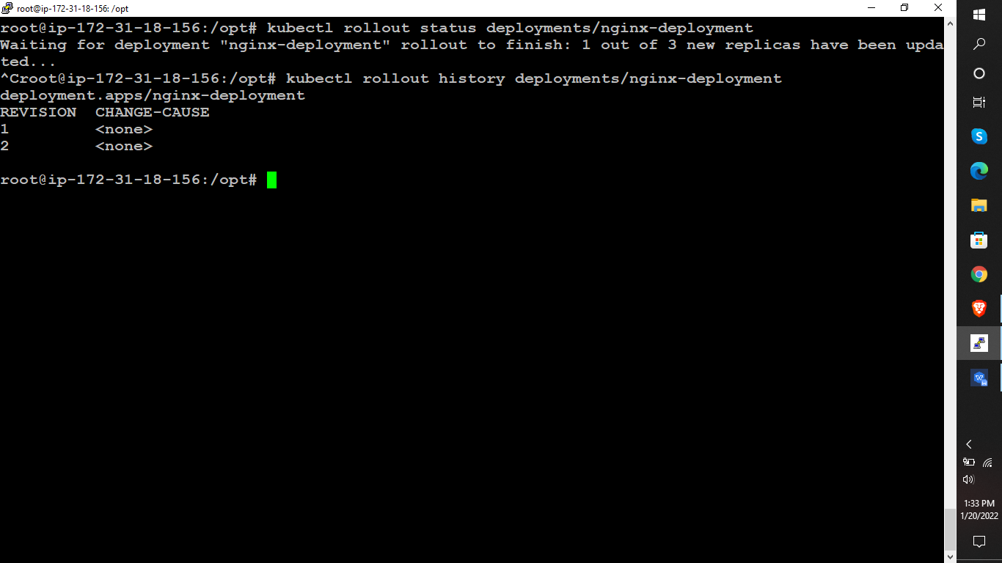

TYPE Deployment-name

| |

Ex: kubectl rollout history deployments/nginx-deployment

And we can undo the updated details in the pods as well by following command:

* **Kubectl rollout undo deploy/nginx-deployment --to-revision=1**
* Here “**--to-revision=1**” is nothing but the recent update u have done and that will be undone.

**Creating secret volumes:** These volumes are used to store the sensitive data such as credentials 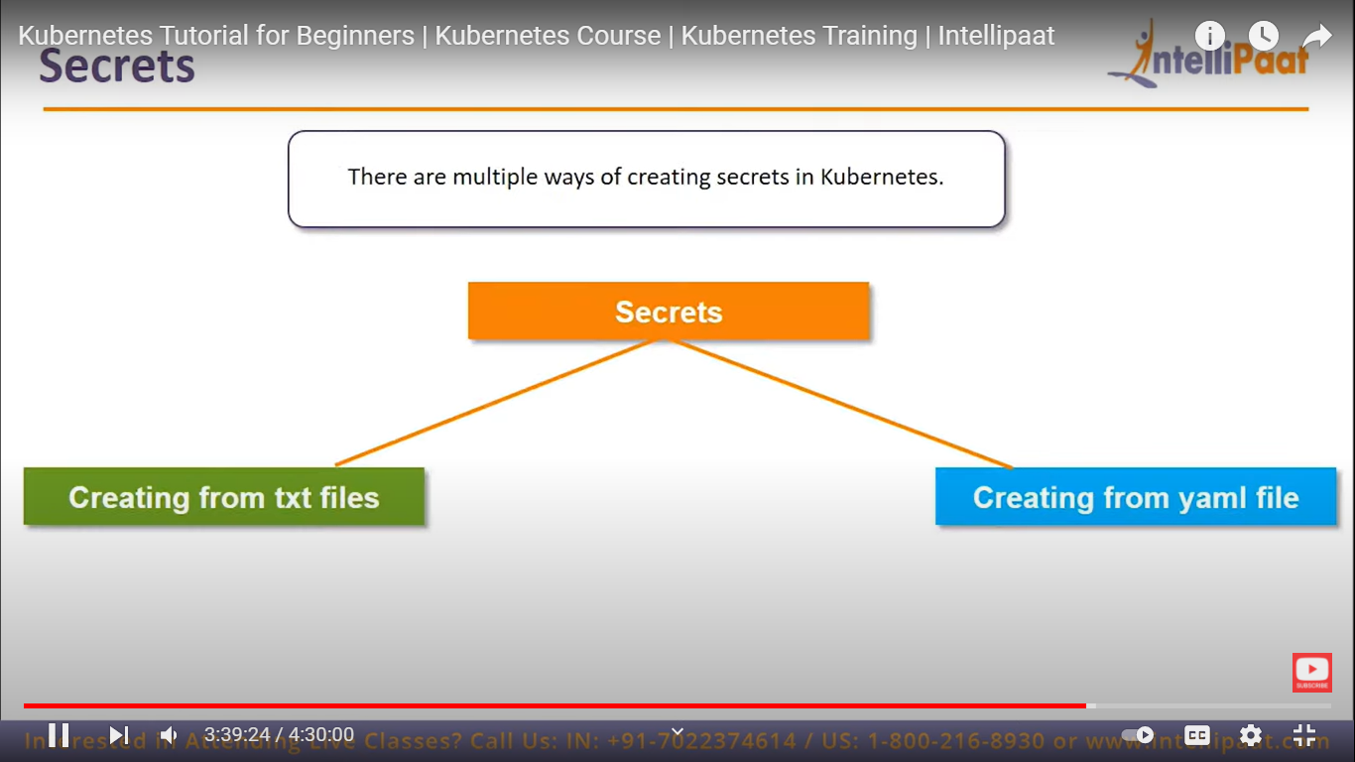

**To create secret file:**

* **echo -n "intellipaat" > ./apikey.txt**
* **kubectl create secret generic apikey --from=file=./apikey.txt**
* <https://kubernetes.io/docs/tasks/inject-data-application/distribute-credentials-secure/>
* Follow above link for secret volume exmaple

1. **What is kubernetes?**

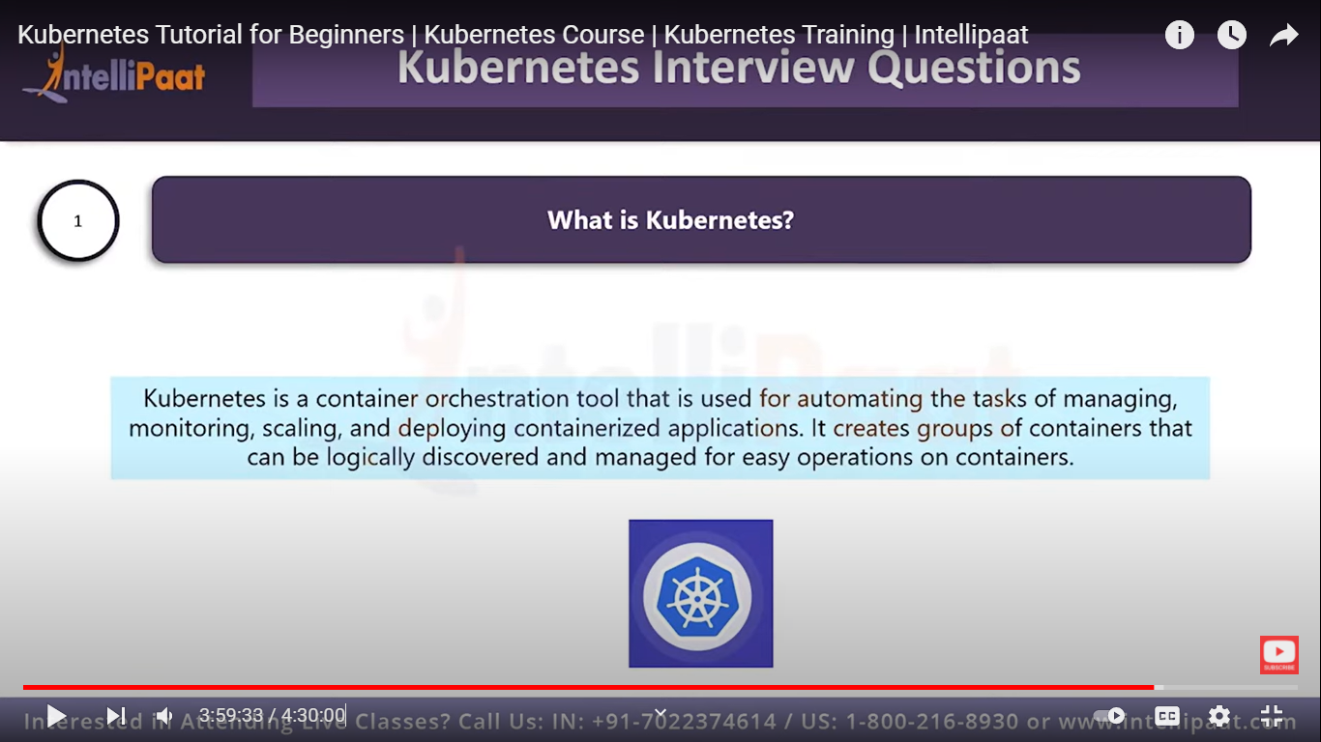

1. **Difference between docker swarm and kubernetes?**

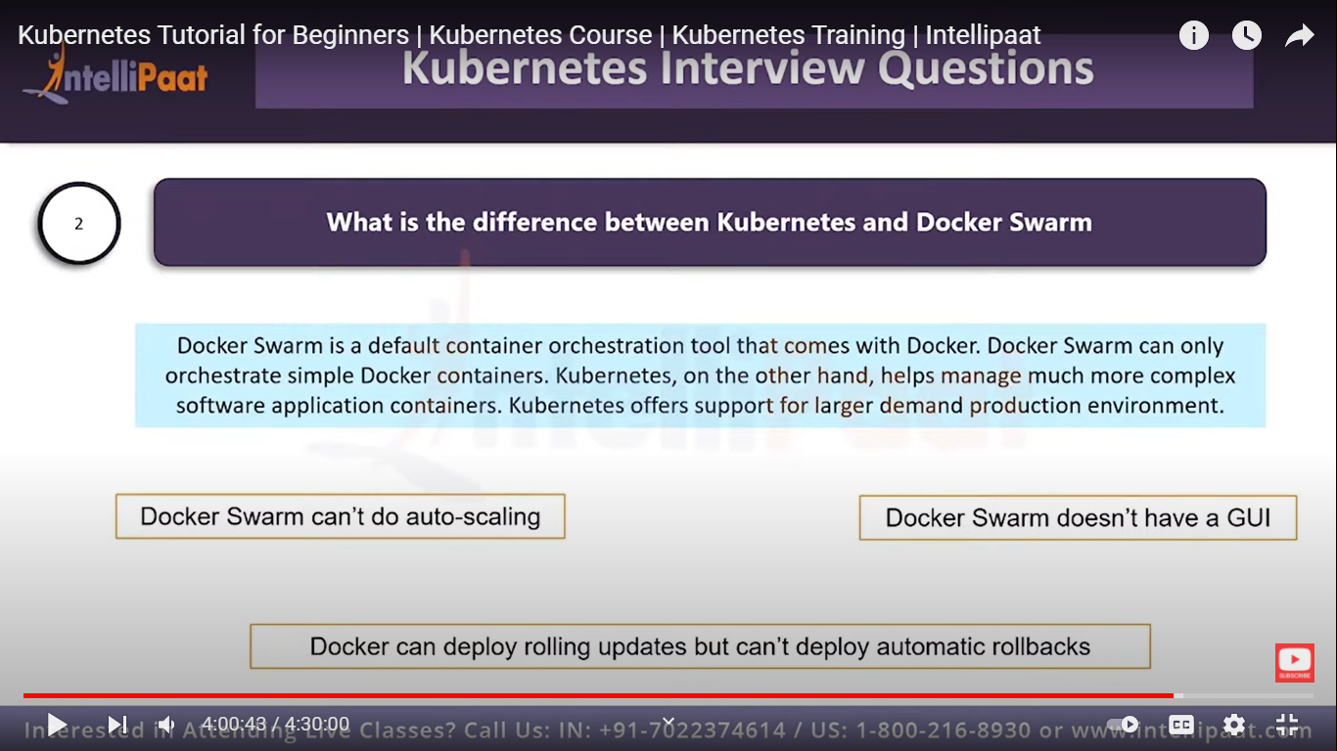

1. **What is Heapster?**

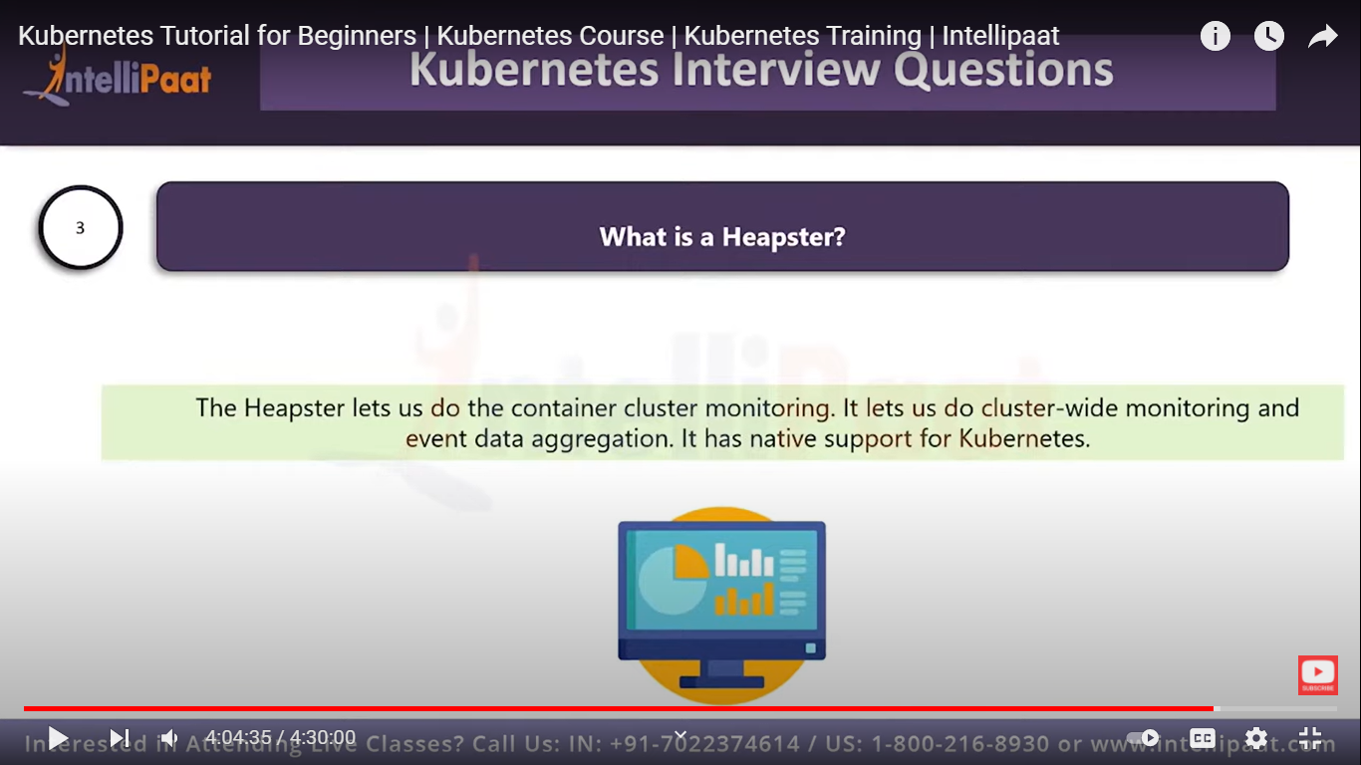

1. **Differenct services in kubernetes ?**
2. **Cluster IP**
3. **External name**
4. **Load balancing servcie**
5. **Node port**
6. **How to set static Ip for K8s load balancer ?**

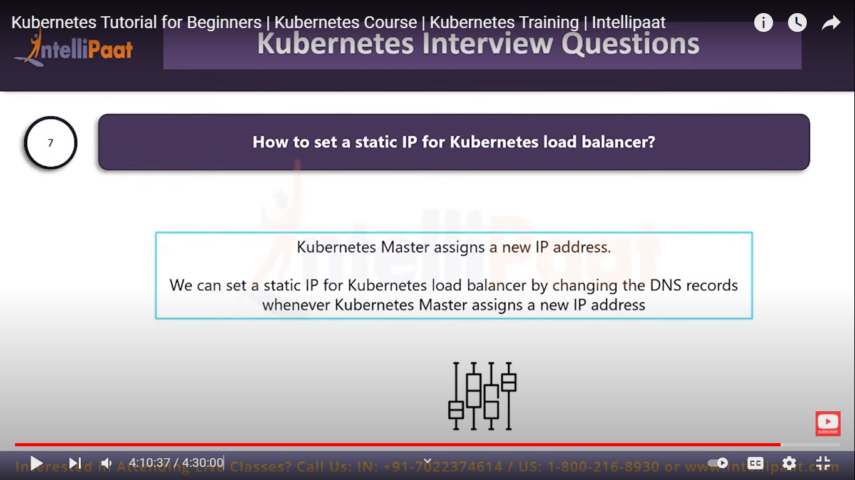

1. **Differnce b/w relplication controllers and replica sets ?**

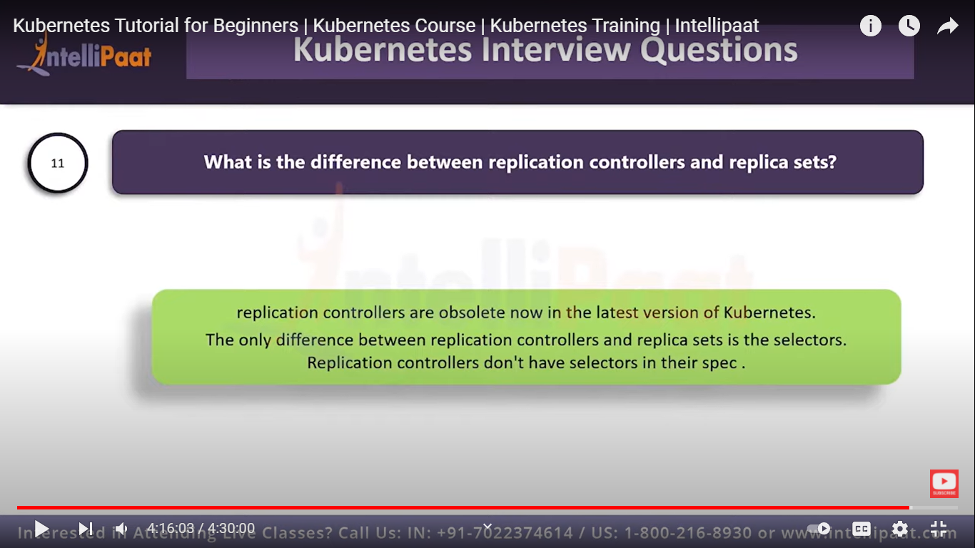

1. **PVC --- persistant volume claim ‘it should be created in the same namespace where thr pod is created’.**